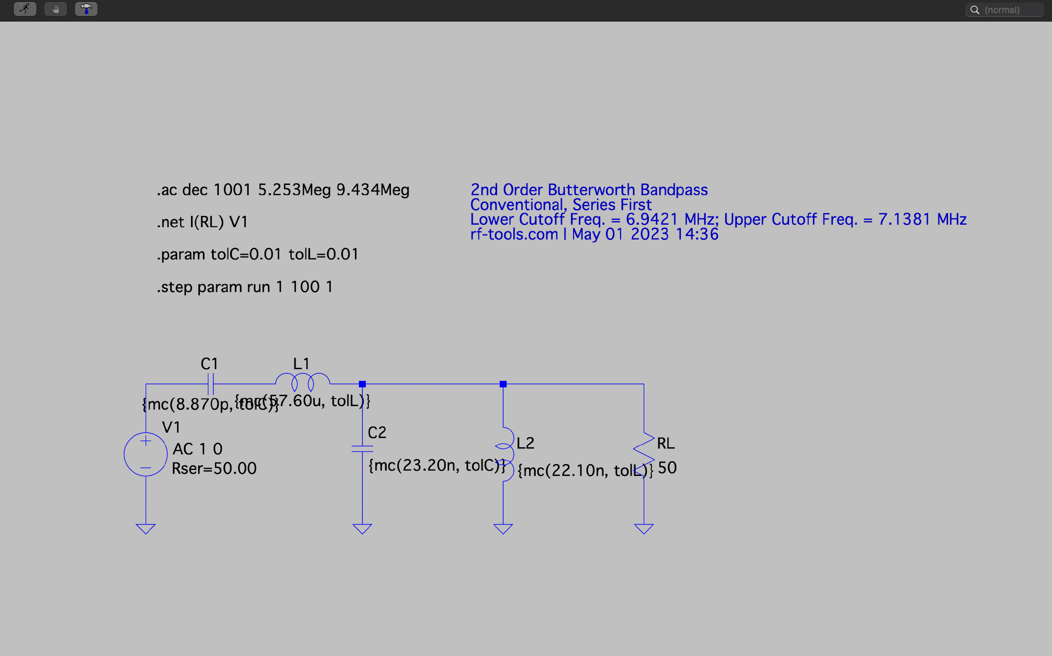

Bandpass filter

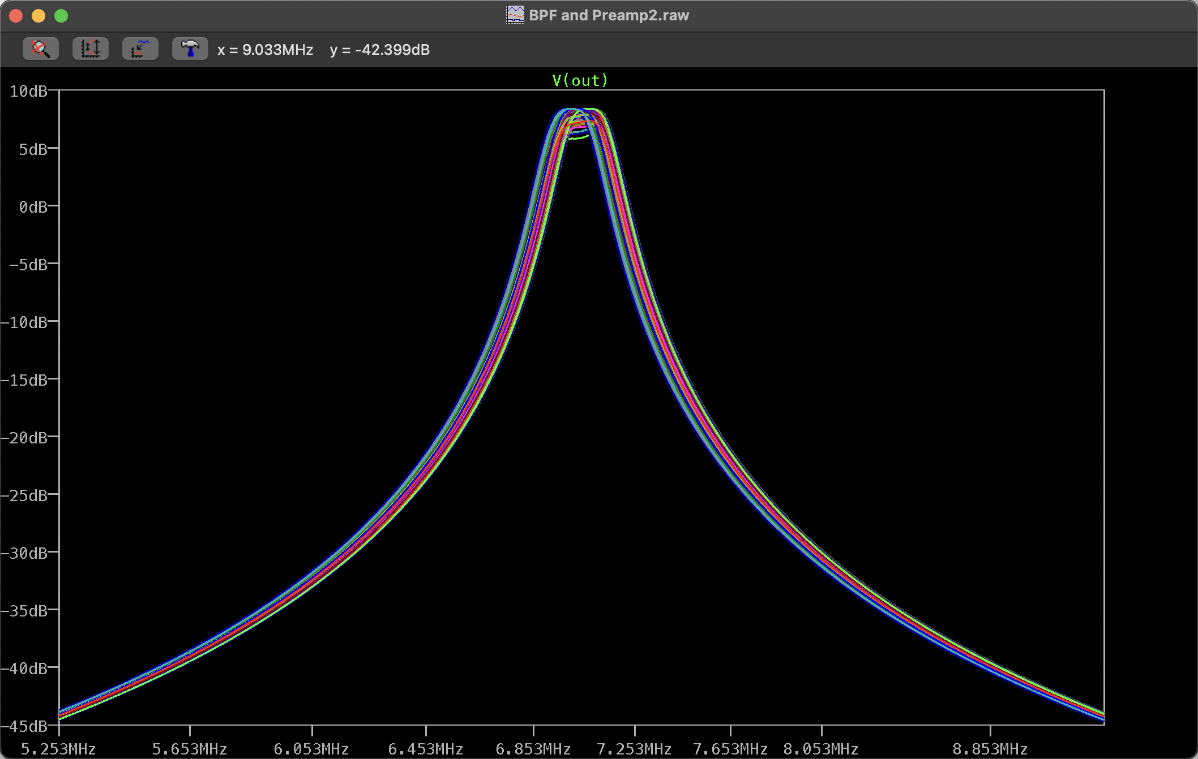

Result 1.0 (frequency response)

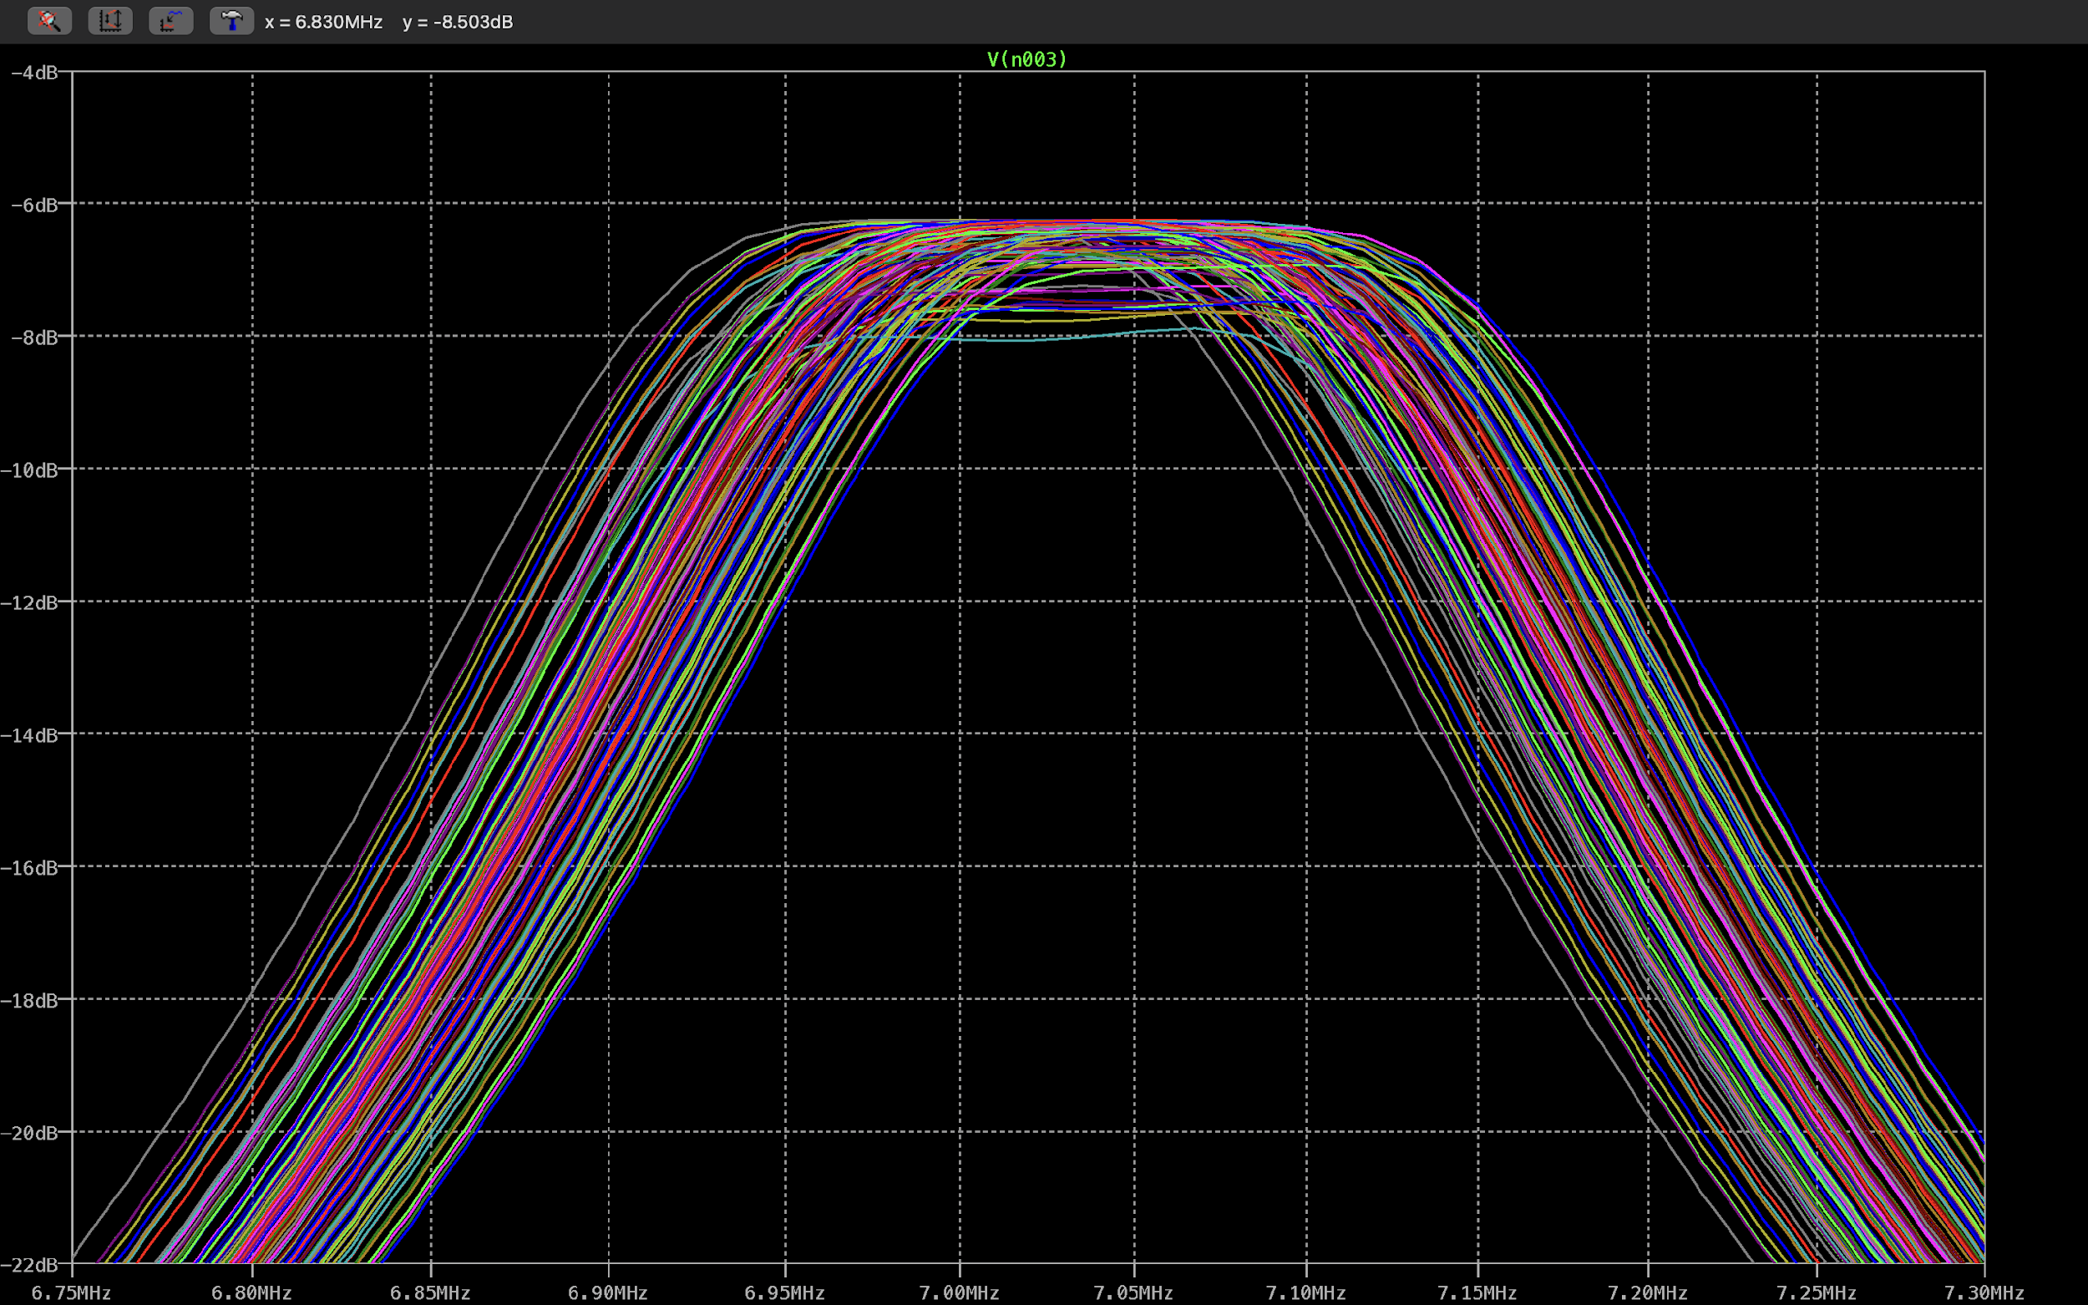

Target range result

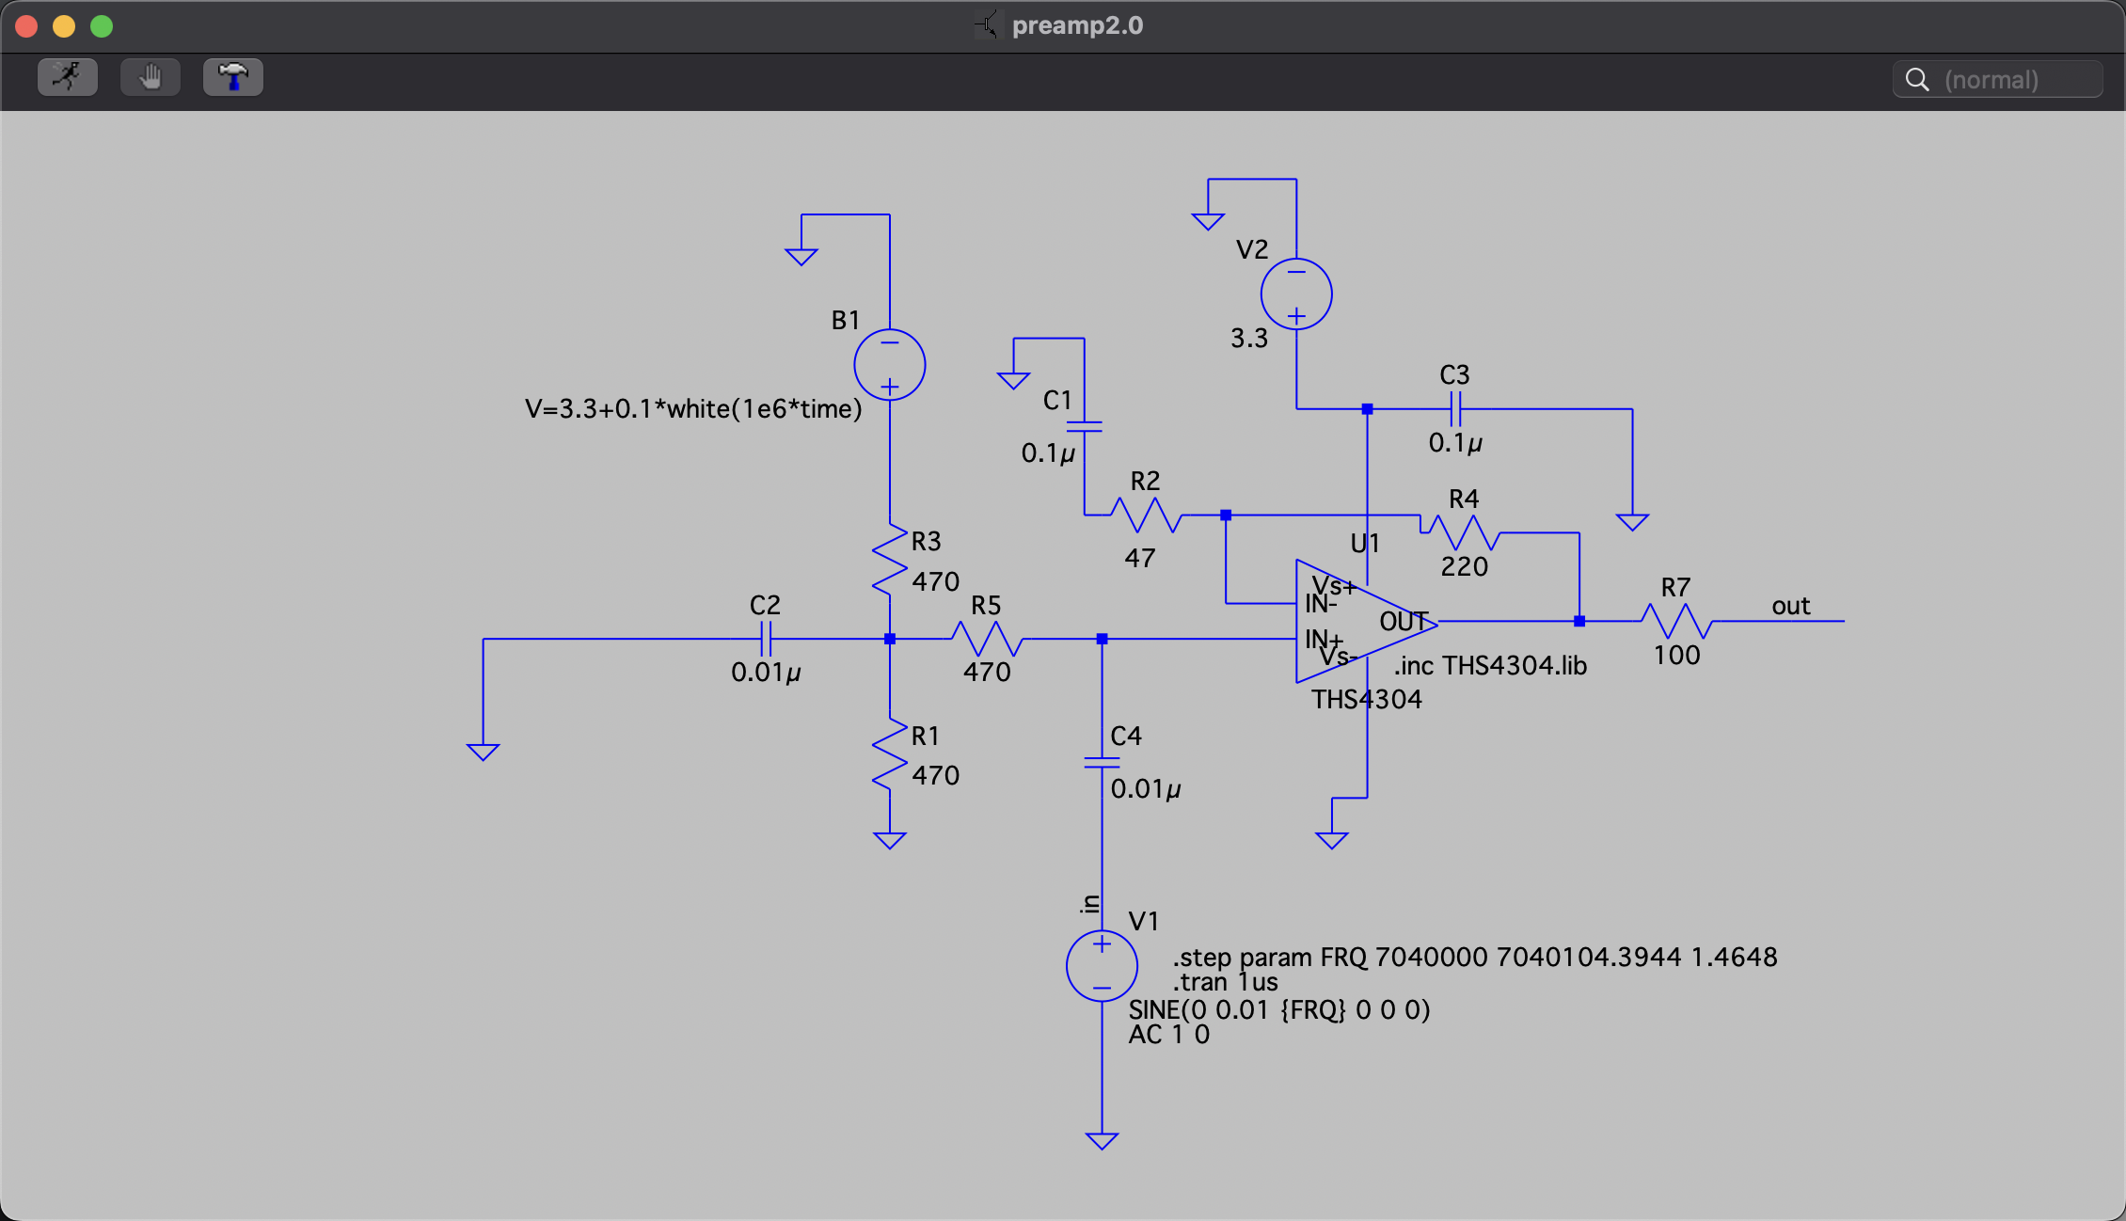

RF preamplifier circuit

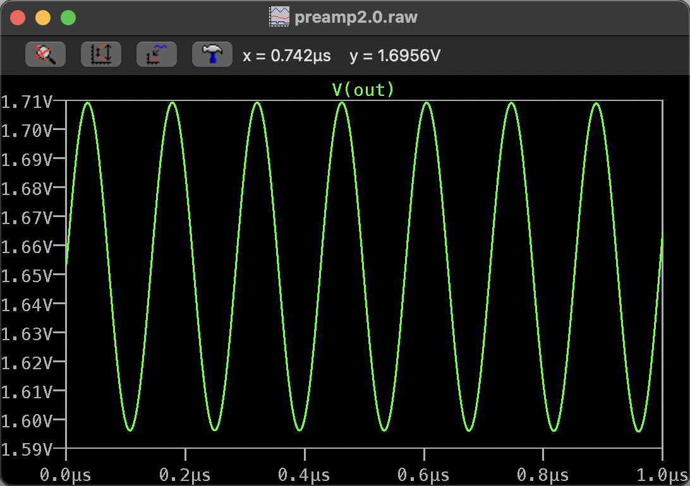

Result 2.0 (magnitude response)

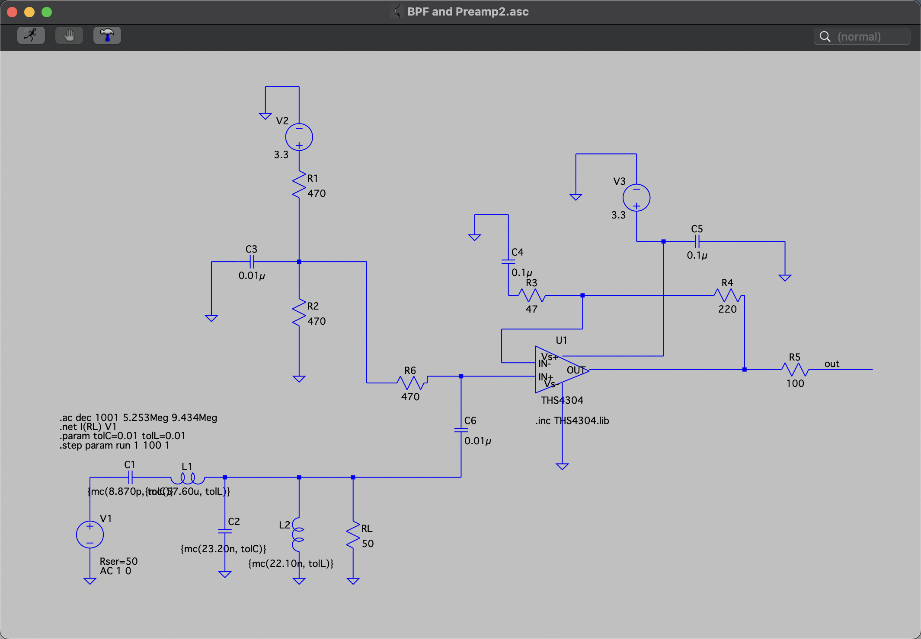

BPF and RF preamplifier circuit

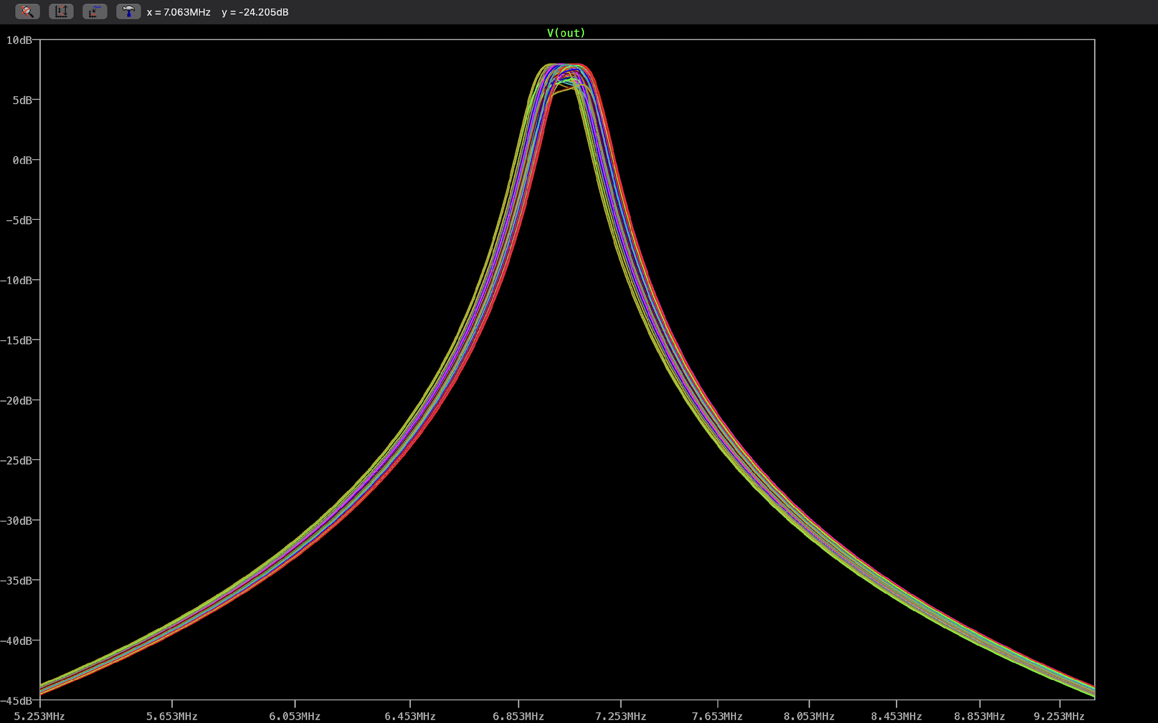

Result 3.0 (frequency response)

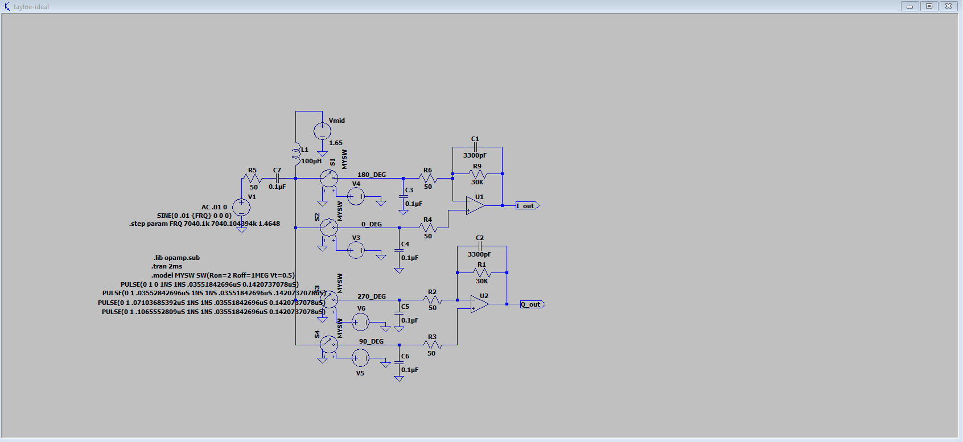

Mixer + audio amplifier circuit

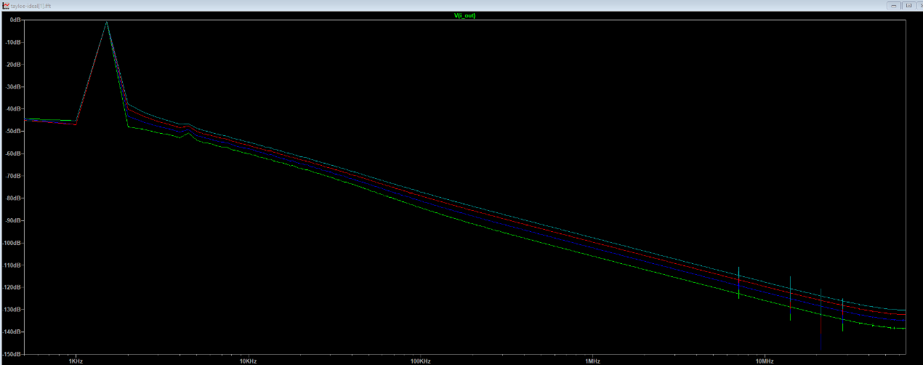

Result 4.0 (frequency response)

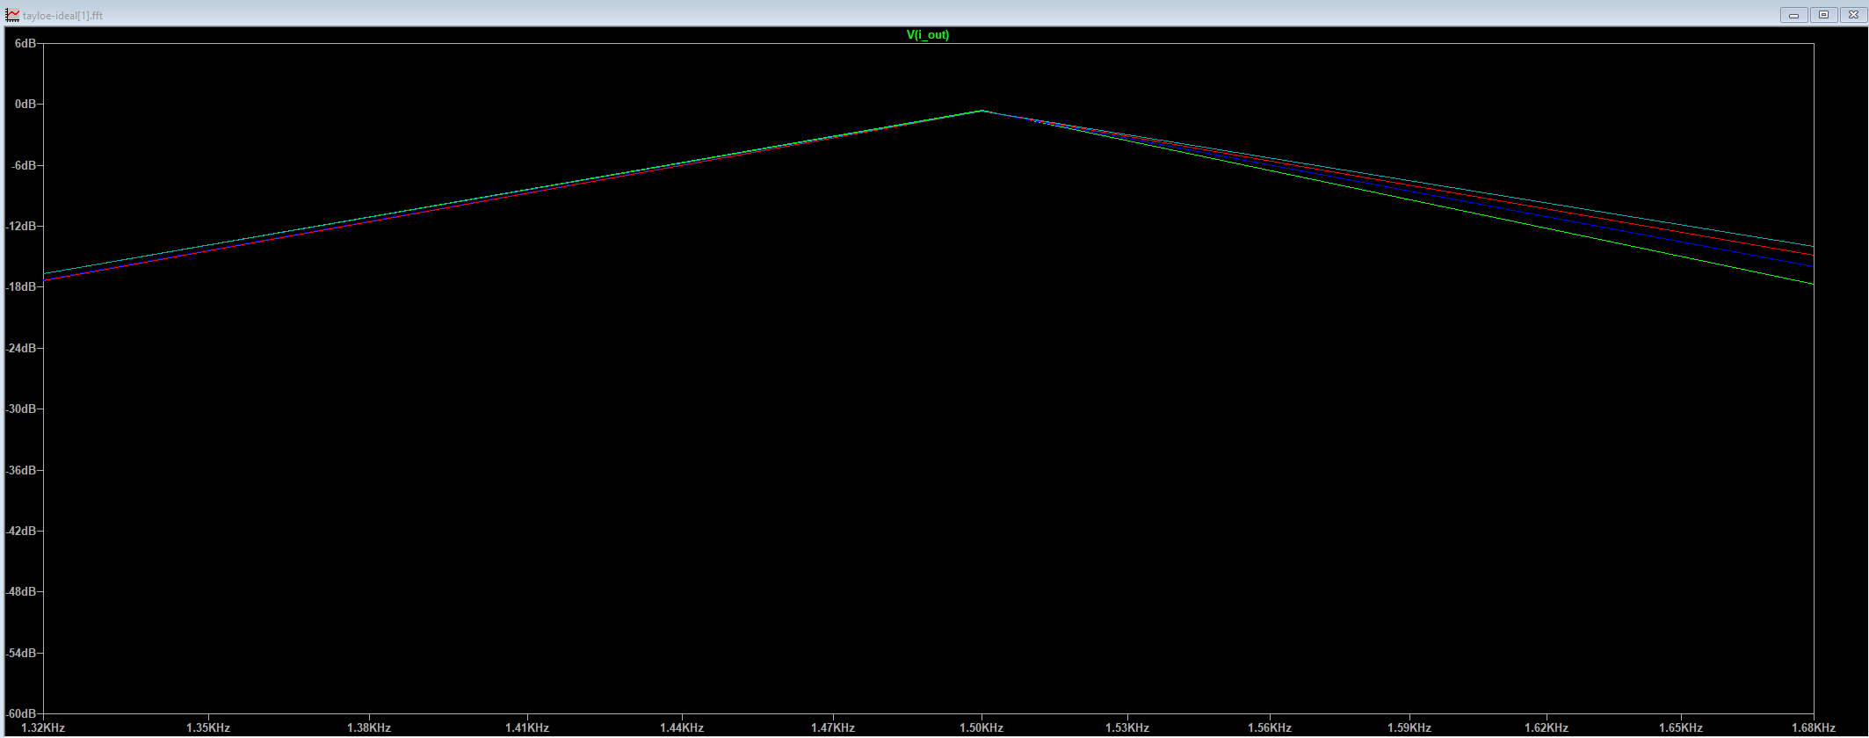

Target range result

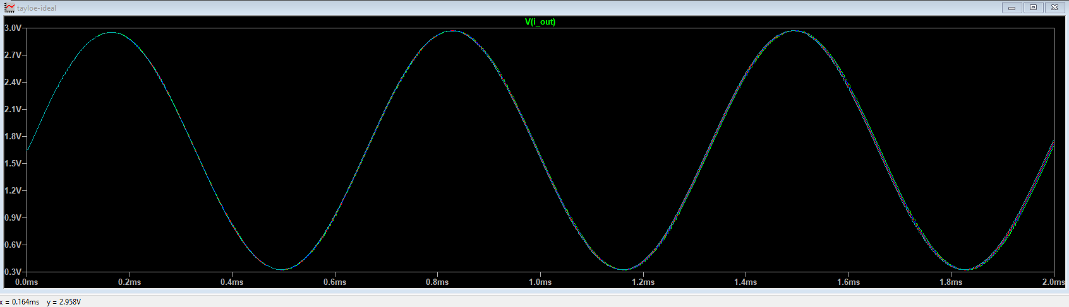

Result 5.0 (magnitude response)

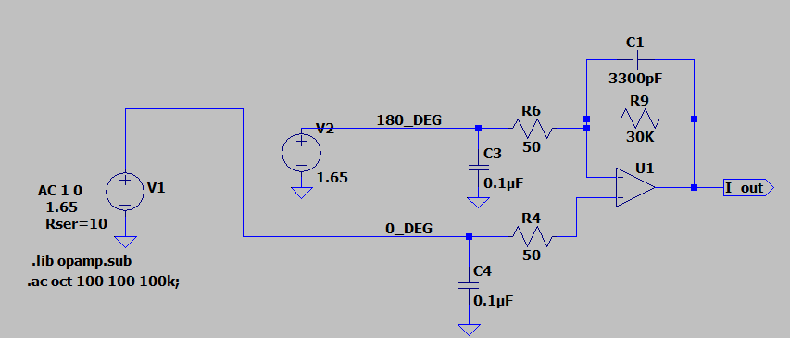

Audio amplifier circuit

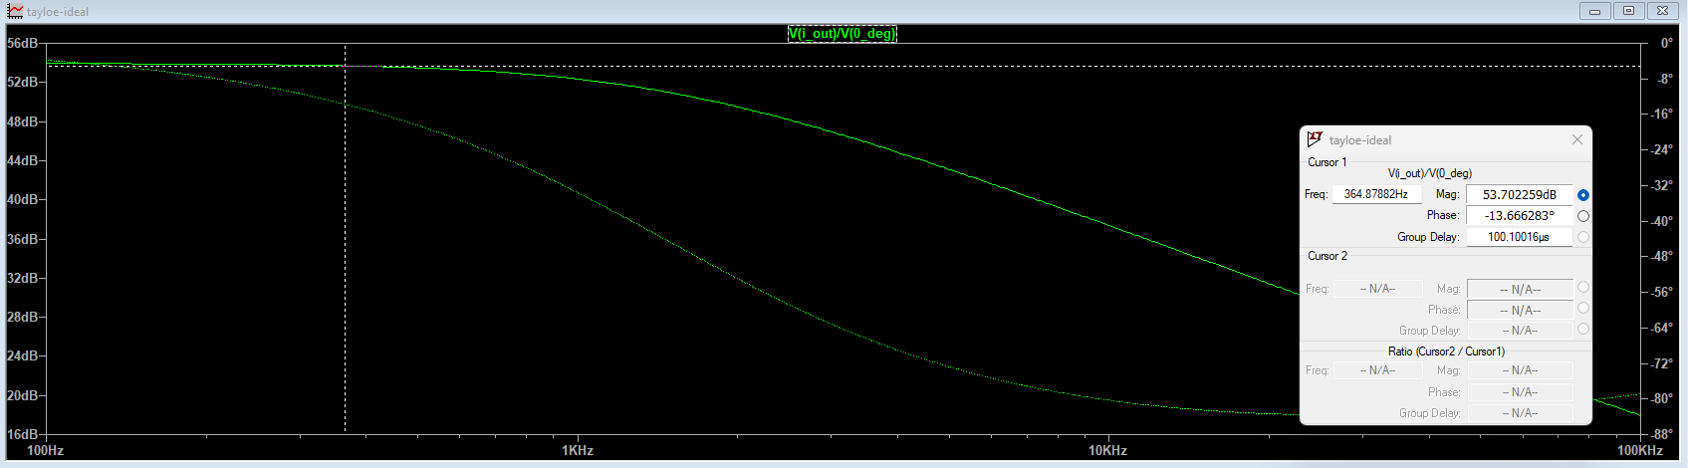

Result 6.0 (frequency response)

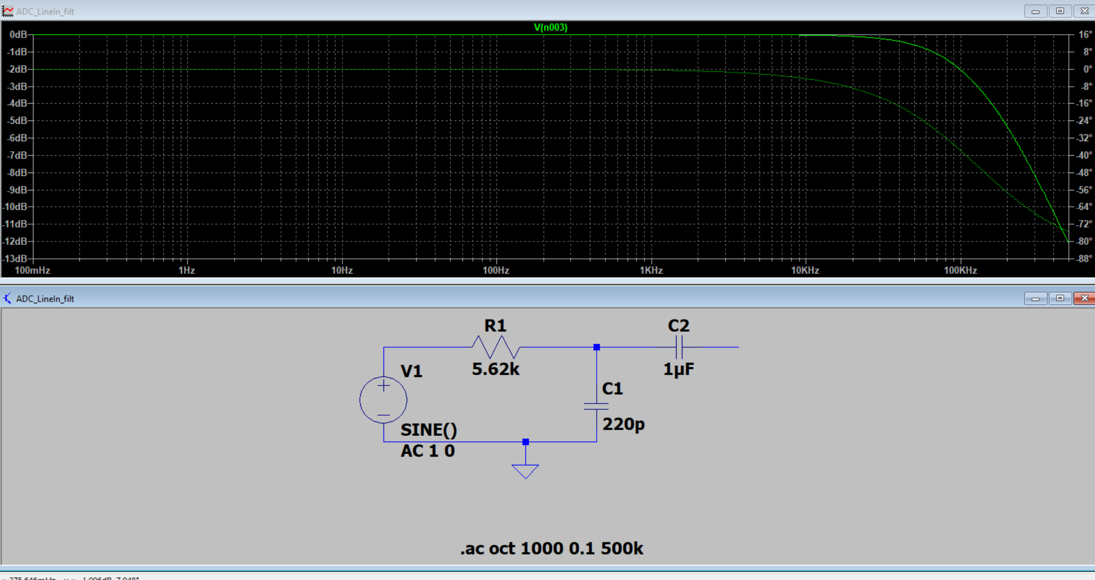

ADC line in filter

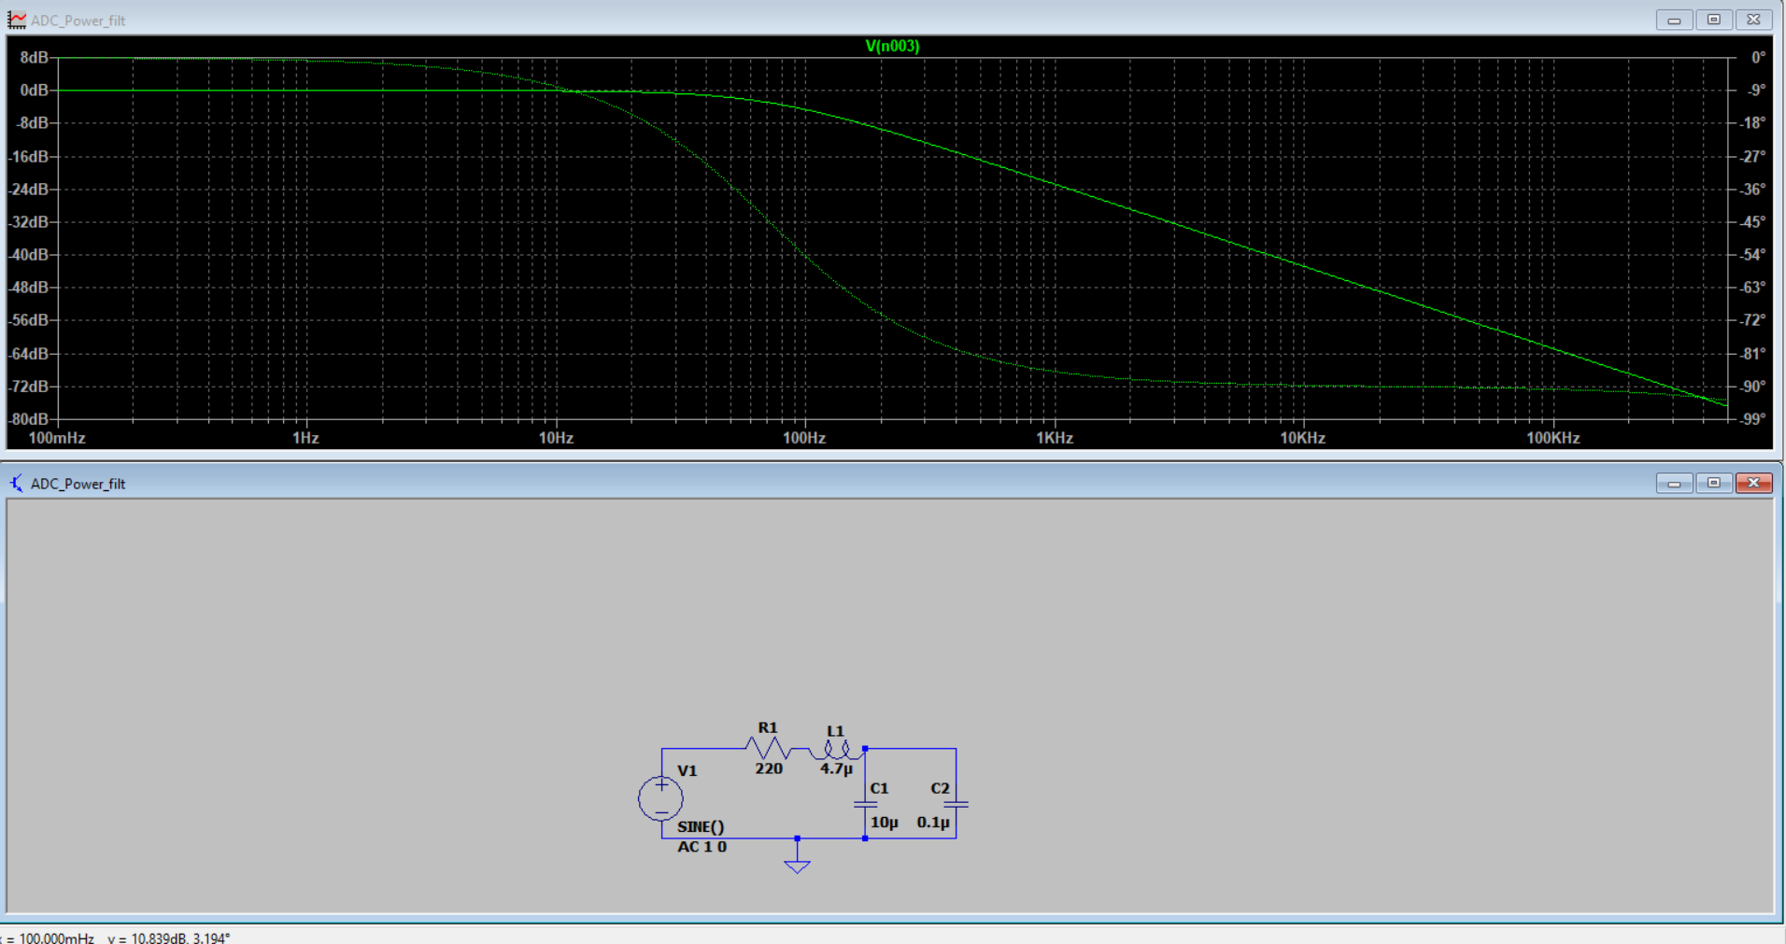

ADC power filter

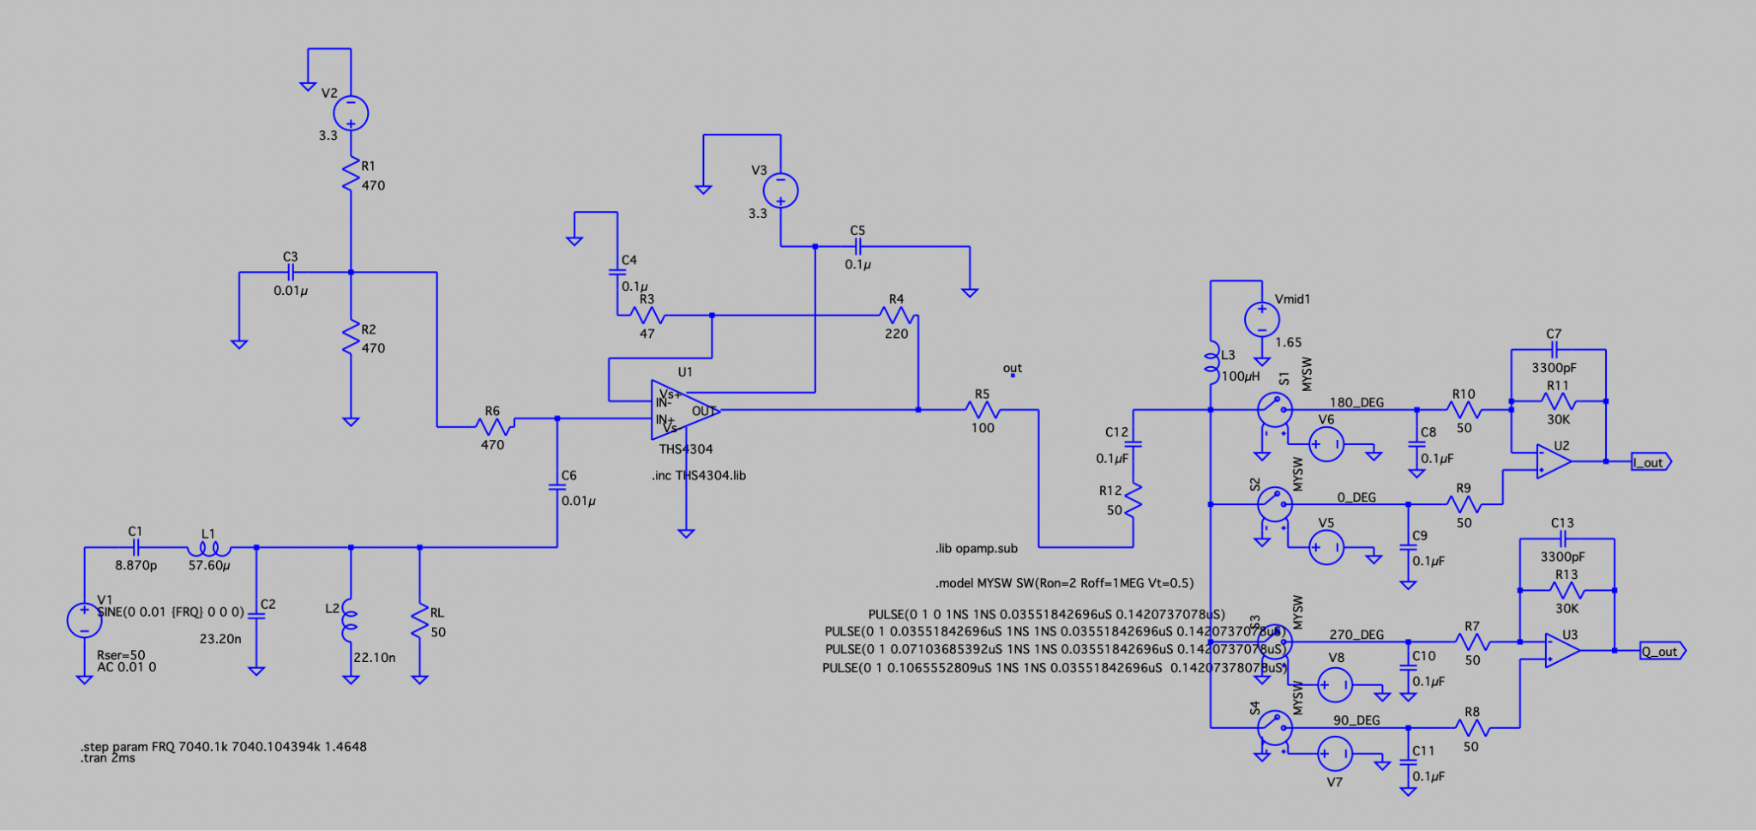

Complete LTSpice simulation (BPF+Preamp+AudioAMP)

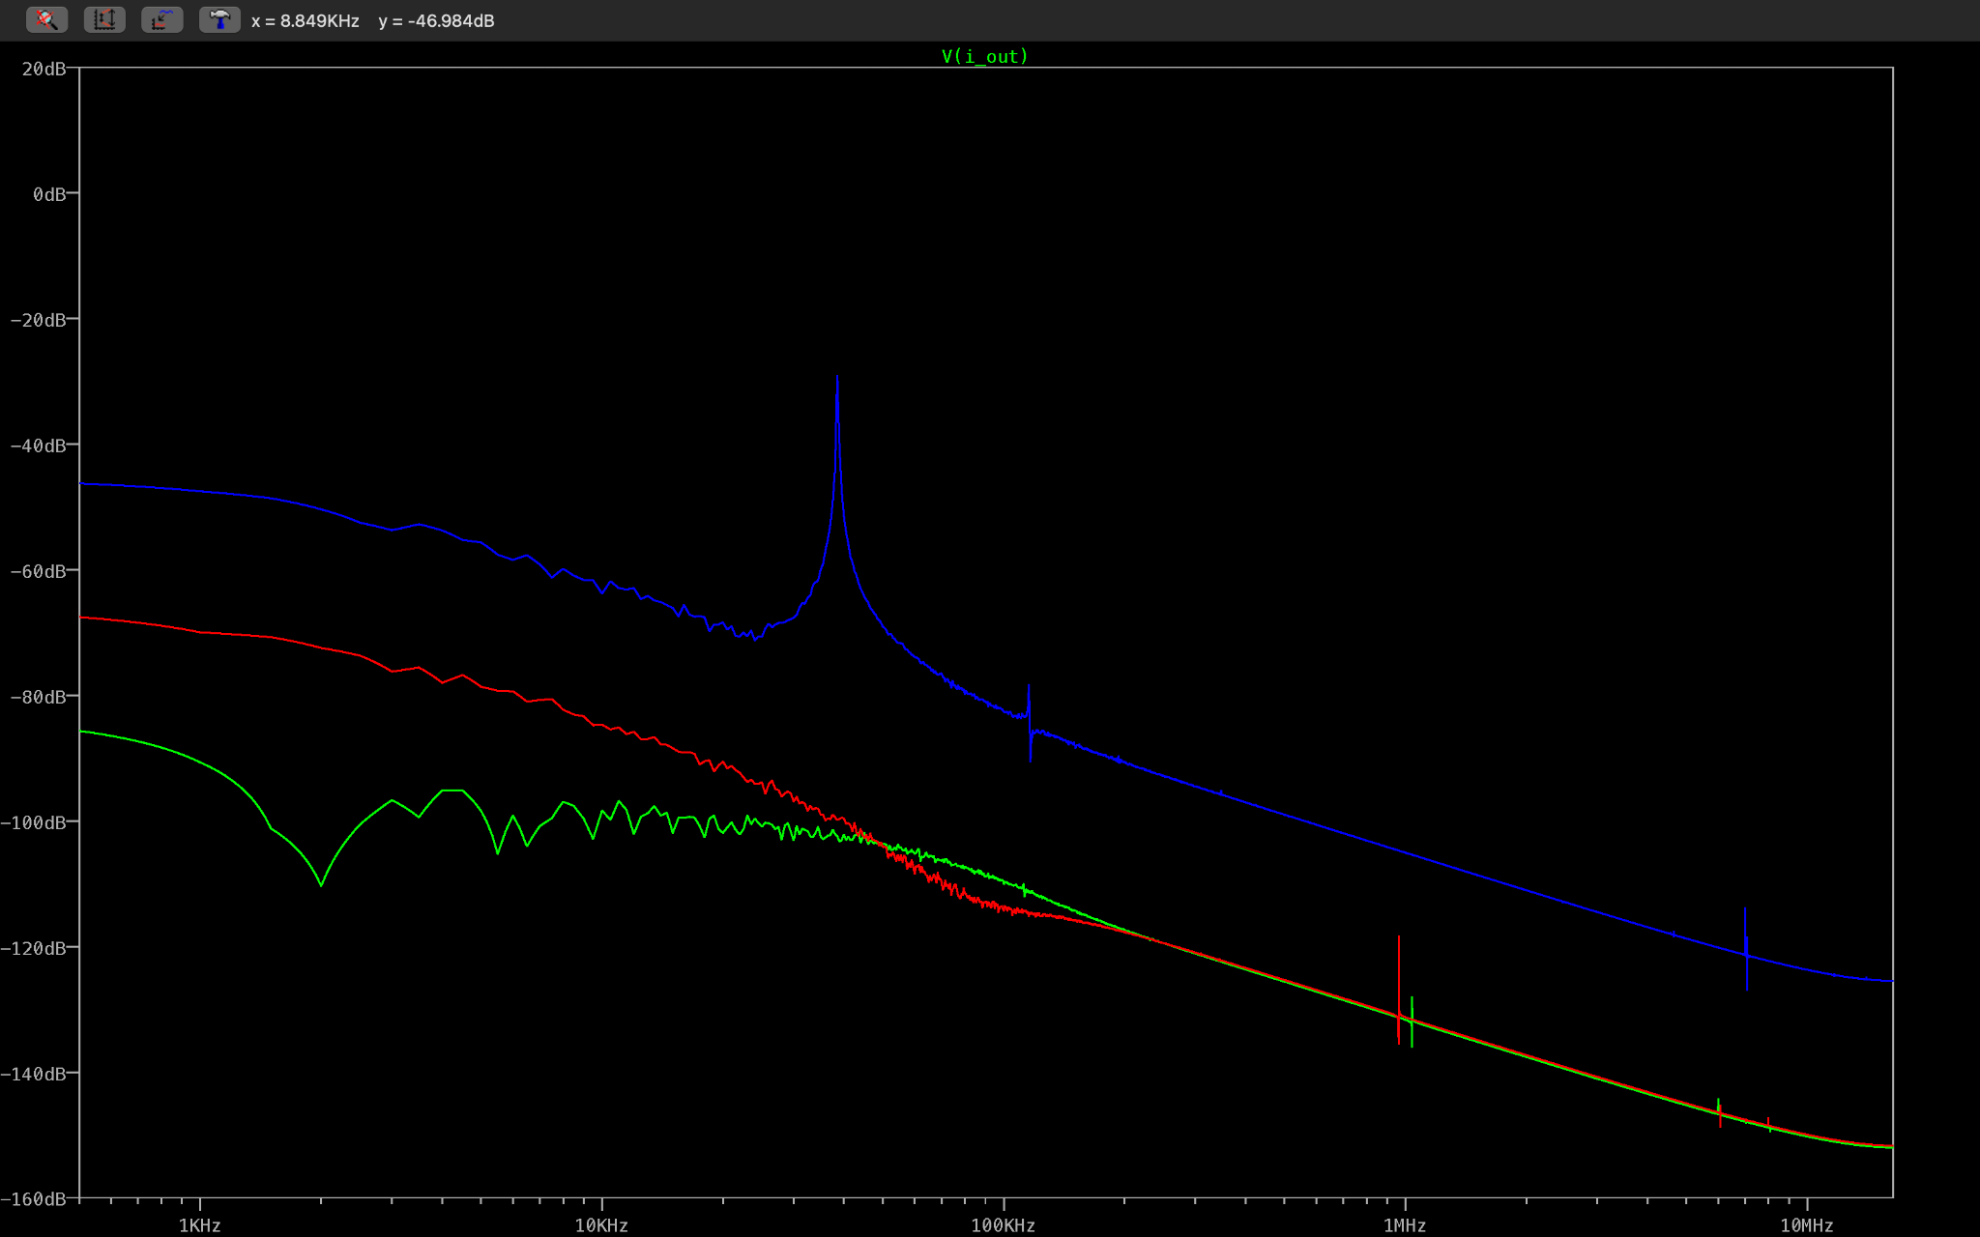

Result 7.0 Transient analysis of frequency on 6MHz(green), 7MHz(blue) 8MHz(red)

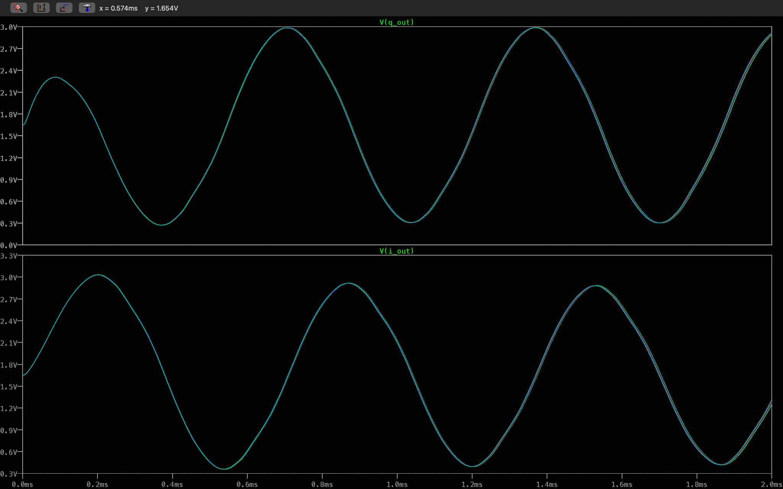

Result 8.0 Transient analysis of frequency ranges from 7.0401MHz to 7.040104394MHz with 1.4648Hz step increment. 90 degree phase shift.

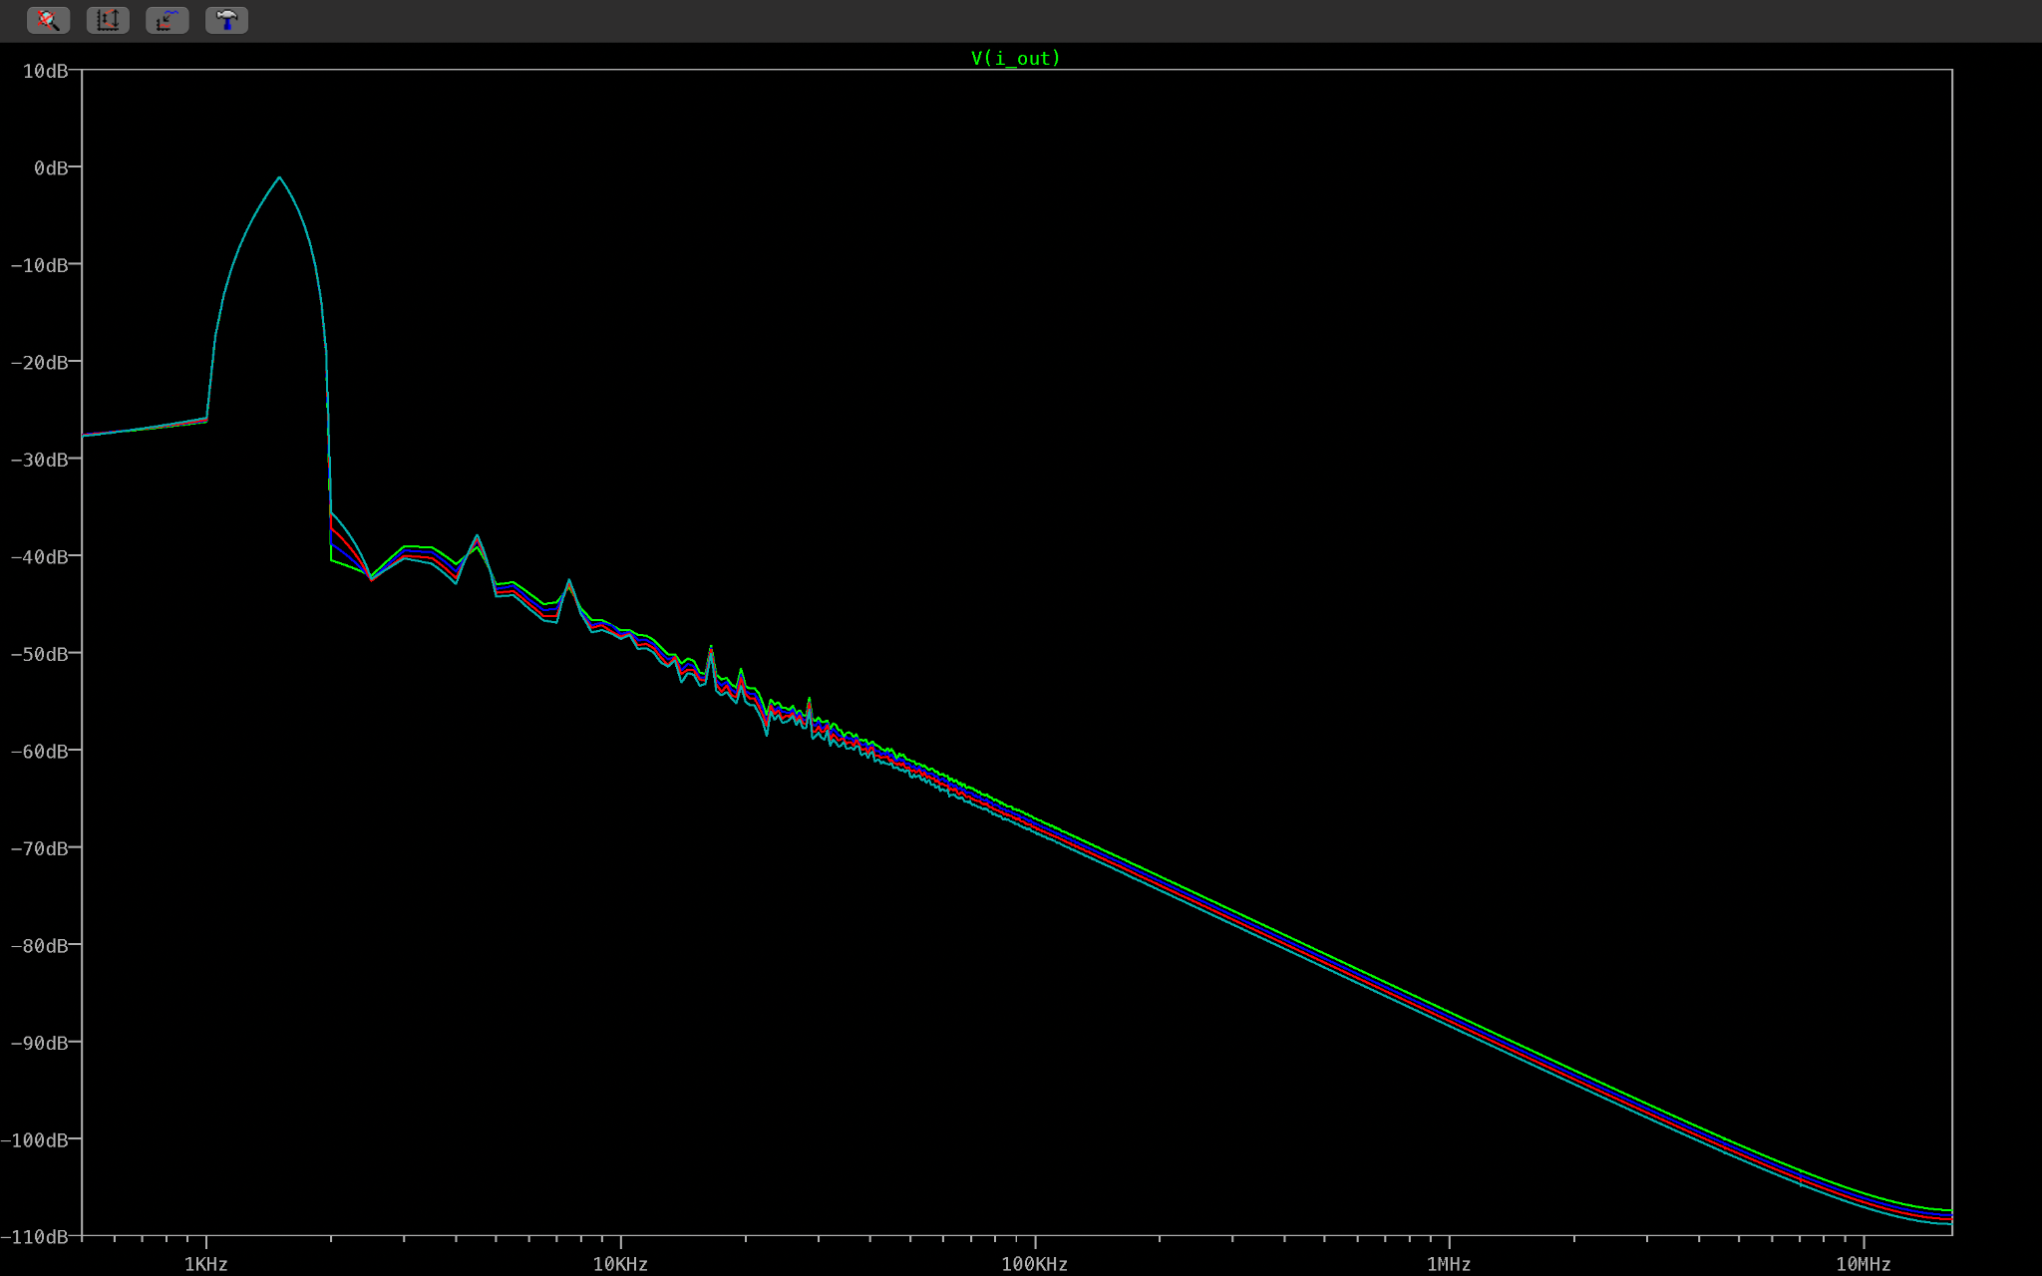

Result 9.0 final output